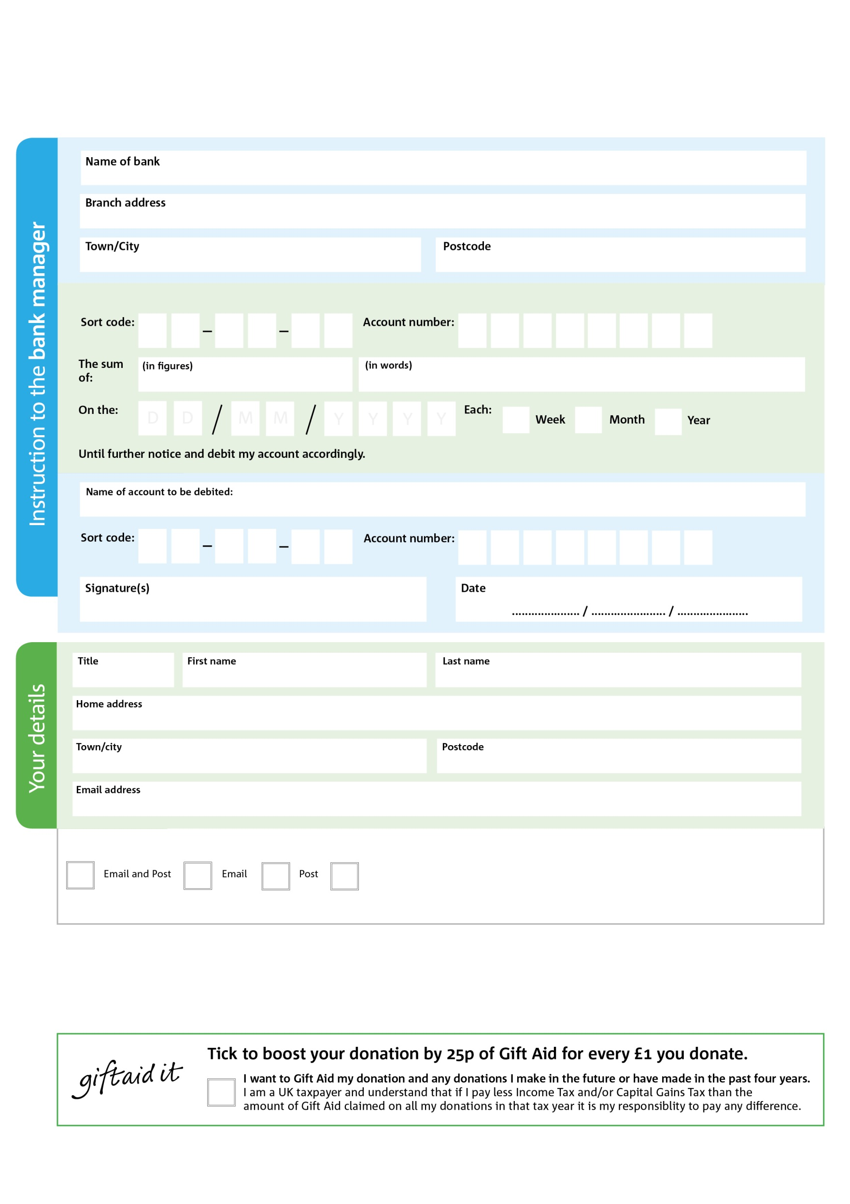

Reg. Charity No: xxxxxx | Reg. in England & Wales

POSTAL ADDRESS: XXXXXXXX Foodbank, XXXXX Road, XXXXXX, TOWN, POSTCODE

**Data protection**

XXXXX Foodbank is committed to protecting your privacy and will process your personal data in accordance with the Data Protection Act 1998. XXXXX Foodbank collects information to keep in touch with you and supply you with information relating to our work. XXXXX Foodbank will never sell or pass your details to anyone who isn’t directly working on our behalf.

We would love to keep you up to date with information about XXXXXXX Foodbank. Please tick your preference:

Please pay XXXXXXXX Foodbank,

You can change your preferences any time by contacting us on XXXXXXXXXXX or emailing us at XXXX@XXXXXXXXXX.foodbank.org.uk

**Standing Order Mandate**

**xxxxxx.foodbank.org.uk**

I do not wish to receive future communications from XXXXXX Foodbank

**Please pass this form onto the foodbank, using the address below, who will save a copy for their records and will send it to your named bank or building society.**